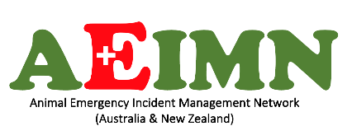
Animal Emergency Incident Management Network
Australia and New Zealand Incorporated

2nd Annual General Meeting
Thursday 5 Oct 2023 7.00 pm AEDT on Zoom
DRAFT Minutes

Present: Professor Julian Slater, David King, Julie Fiedler, Gina Kemp, Warren Rees, Drs. Janet & Mark Buckerfield. Dr Peter Gillespie, Patrice Palleson-Putt, Erica Honey, Dr Steve De Gray, Rod Stebbing, Dr Kathy Klein, Assoc. Prof. Mel Taylor, Ben Birbeck.
Apologies: Christine Smith, Fiona Ryan, Sue Leslie, Susan Turner-Davis, Carolyn Press. Anthony Hatch.

- Meeting opening: Professor Slater welcomed all in attendance. Professor Slater and Gina Kemp undertook acknowledgments of Country for Australia and New Zealand, respectively.
- Record of attendance and apologies (see above). No proxy forms were received.
- Minutes of the previous AGM. The draft Minutes have been posted online all year.
Julie Fiedler proposed accepting the Minutes of the last AGM. David King seconded. All in favour.
- Chairperson’s Report. Professor Slater summarised the previously circulated Chair’s report.
- Treasurer’s Report. Erica Honey summarised the previously circulated Annual Financial Report.
Rod Stebbing proposed accepting the Annual Report, incorporating the Chairperson’s Report and the Treasurer’s Annual Financial Reports. David King seconded. All in favour.
- Elect members of the Board 2023/2024
Professor Slater explained that the AEIMN Board has previously approved increasing the number of Board members to nine. The meeting was handed over to Dr Kathy Klein.
Dr Klein dissolved the current board and declared all positions vacant. There being no voting required, all positions were considered duly elected. Professor Slater returned to continue chairing the meeting. The 2023/2024 Board names are listed below.
1 | Professor Julian Slater
2 | Erica Honey
3 | Gina Kemp
4 | Rod Stebbing
5 | Fabian Stangherlin
6 | Dr Christine Smith
7 | David King
8 | Julie Fiedler
9 | Patrice Palleson-Putt
- There being no further business, the meeting closed at 7.25 pm.

